Binary Search Tree
- Binary Search tree can be defined as a class of binary trees, in which the nodes are arranged in a specific order. This is also called ordered binary tree.
- In a binary search tree, the value of all the nodes in the left sub-tree is less than the value of the root.
- Similarly, value of all the nodes in the right sub-tree is greater than or equal to the value of the root.
- This rule will be recursively applied to all the left and right sub-trees of the root.
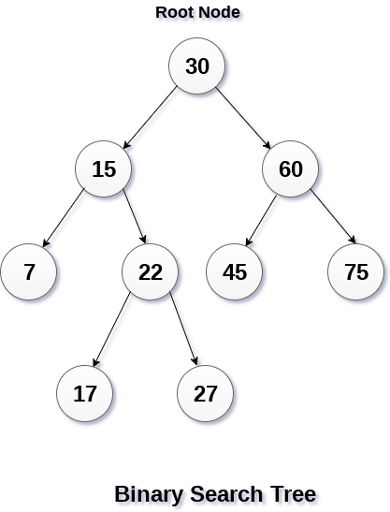
A Binary search tree is shown in the above figure. As the constraint applied on the BST, we can see that the root node 30 doesn't contain any value greater than or equal to 30 in its left sub-tree and it also doesn't contain any value less than 30 in its right sub-tree.

Advantages of using binary search tree
- Searching become very efficient in a binary search tree since, we get a hint at each step, about which sub-tree contains the desired element.
- The binary search tree is considered as efficient data structure in compare to arrays and linked lists. In searching process, it removes half sub-tree at every step. Searching for an element in a binary search tree takes o(log₂n) time. In worst case, the time it takes to search an element is 0(n).
- It also speed up the insertion and deletion operations as compare to that in array and linked list.

Q. Create the binary search tree using the following data elements.
43, 10, 79, 90, 12, 54, 11, 9, 50
- Insert 43 into the tree as the root of the tree.
- Read the next element, if it is lesser than the root node element, insert it as the root of the left sub-tree.
- Otherwise, insert it as the root of the right of the right sub-tree.

Operations on Binary Search Tree
There are many operations which can be performed on a binary search tree.
SN | Operation | Description
1 | Searching in BST | Finding the location of some specific element in a binary search tree.
2 | Insertion in BST | Adding a new element to the binary search tree at the appropriate location so that the property of BST do not violate.
3 | Deletion in BST | Deleting some specific node from a binary search tree. However, there can be various cases in deletion depending upon the number of children, the node have.

Searching
Searching means finding or locating some specific element or node within a data structure. However, searching for some specific node in binary search tree is pretty easy due to the fact that, element in BST are stored in a particular order.
- Compare the element with the root of the tree.
- If the item is matched then return the location of the node.
- Otherwise check if item is less than the element present on root, if so then move to the left sub-tree.
- If not, then move to the right sub-tree.
- Repeat this procedure recursively until match found.
- If element is not found then return NULL.

Algorithm:
Search (ROOT, ITEM)
- Step 1: IF ROOT -> DATA = ITEM OR ROOT = NULL
Return ROOT
ELSE
IF ROOT < ROOT -> DATA
Return search(ROOT -> LEFT, ITEM)
ELSE
Return search(ROOT -> RIGHT,ITEM)
[END OF IF]
[END OF IF]
- Step 2: END

Insertion
Insert function is used to add a new element in a binary search tree at appropriate location. Insert function is to be designed in such a way that, it must node violate the property of binary search tree at each value.
- Allocate the memory for tree.
- Set the data part to the value and set the left and right pointer of tree, point to NULL.
- If the item to be inserted, will be the first element of the tree, then the left and right of this node will point to NULL.
- Else, check if the item is less than the root element of the tree, if this is true, then recursively perform this operation with the left of the root.
- If this is false, then perform this operation recursively with the right sub-tree of the root.

Insert (TREE, ITEM)
- Step 1: IF TREE = NULL
Allocate memory for TREE
SET TREE -> DATA = ITEM
SET TREE -> LEFT = TREE -> RIGHT = NULL
ELSE
IF ITEM < TREE -> DATA
Insert(TREE -> LEFT, ITEM)
ELSE
Insert(TREE -> RIGHT, ITEM)
[END OF IF]
[END OF IF]
- Step 2: END

Deletion
Delete function is used to delete the specified node from a binary search tree. However, we must delete a node from a binary search tree in such a way, that the property of binary search tree doesn't violate. There are three situations of deleting a node from binary search tree.

The node to be deleted is a leaf node
It is the simplest case, in this case, replace the leaf node with the NULL and simple free the allocated space.

The node to be deleted has only one child.
In this case, replace the node with its child and delete the child node, which now contains the value which is to be deleted. Simply replace it with the NULL and free the allocated space.

The node to be deleted has two children.
The node which is to be deleted, is replaced with its in-order successor or predecessor recursively until the node value (to be deleted) is placed on the leaf of the tree. After the procedure, replace the node with NULL and free the allocated space.

Find the node with minimum value in a Binary Search Tree

Traverse the node from root to left recursively until left is NULL.
The node whose left is NULL is the node with minimum value.

Find the node with maximum value in a Binary Search Tree

Traverse the node from root to right recursively until right is NULL.
The node whose right is NULL is the node with maximum value.

Find k-th smallest element in BST
The Inorder Traversal of a BST traverses the nodes in increasing order. So the idea is to traverse the tree in Inorder. While traversing, keep track of the count of the nodes visited. If the count becomes k, print the node.

